**ANNEXURE C**

**DETAILS OF VEHICLES FOR DISPOSAL**

**1. VEHICLE DETAILS**

|  |  |
| --- | --- |
| * **Registration nr** | CX63BJGP |
| * **Make of Vehicle** | Toyota Hilux 2.5 D/C |
| * **Engine nr** | 2KDA29**** |
| * **VIN:** | AHTER39G70860**** |
| * **Year Model** | 2013 |
| * **Current kilometres** | 157853 |
| * **Location** | Environmental House, Pretoria |

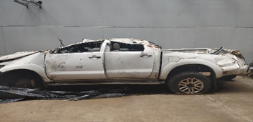 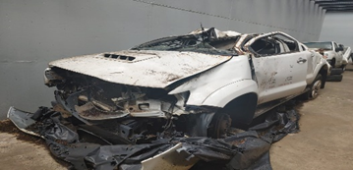

1. **VEHICLE DETAILS**

|  |  |
| --- | --- |
| * **Registration nr** | CX63BRGP |
| * **Make of Vehicle** | Toyota Hilux 2.5 D/C |
| * **Engine nr** | 1KDA17**** |
| * **VIN:** | AHTFZ209G40909**** |
| * **Year Model** | 2013 |
| * **Current kilometres** | 58374 |
| * **Location** | Environment House, Pretoria |

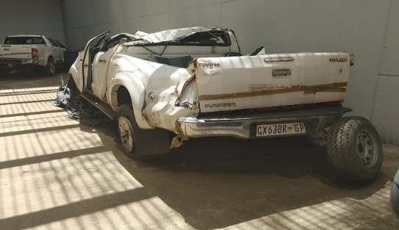 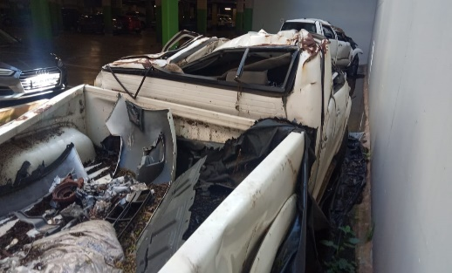

1. **VEHICLE DETAILS**

|  |  |
| --- | --- |
| * **Registration nr** | CA76630 |
| * **Make of Vehicle** | Toyota Hilux 3.0 D/C |
| * **Engine nr** | 1KDA11**** |
| * **VIN:** | AHTFZ29G50909**** |
| * **Year Model** | 2013 |
| * **Current kilometres** | 24900 |
| * **Location** | Port Elizabeth |

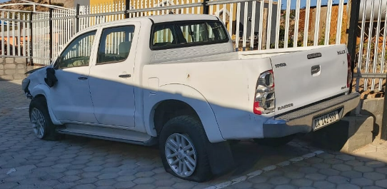

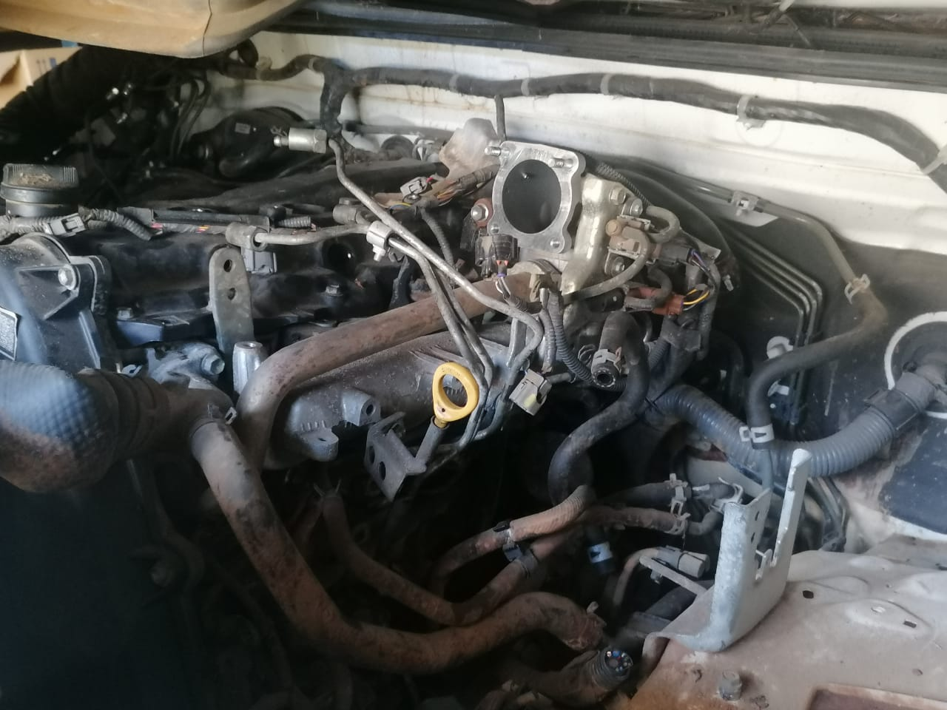

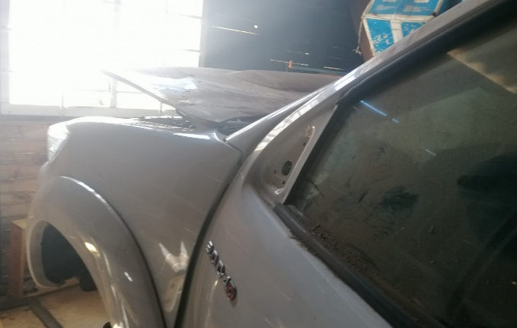

1. **VEHICLE DETAILS**

|  |  |
| --- | --- |
| * **Registration nr** | RWP386GP |
| * **Make of Vehicle** | Nissan Hardbody2.0L |
| * **Engine nr** | TD2774**** |
| * **VIN:** | ADNJ420000E01**** |
| * **Year Model** | 1998 |
| * **Current kilometres** | 152000 |
| * **Location** | Location: Environment House, Pretoria |

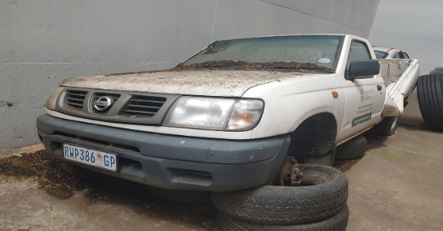 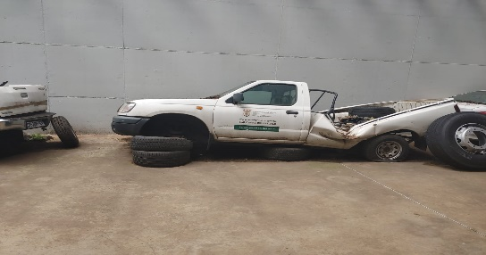

1. **VEHICLE DETAILS**

|  |  |
| --- | --- |
| * **Registration nr** | CA141599 |
| * **Make of Vehicle** | Toyota Hilux |
| * **Engine nr** | 1KDA11**** |
| * **VIN:** | AHTFZ29G50909**** |
| * **Year Model** | 2013 |
| * **Current kilometres** | 60000 |
| * **Location** | Springbok, Northern Cape |

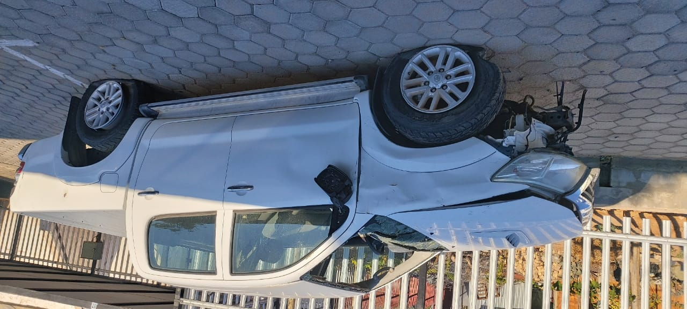 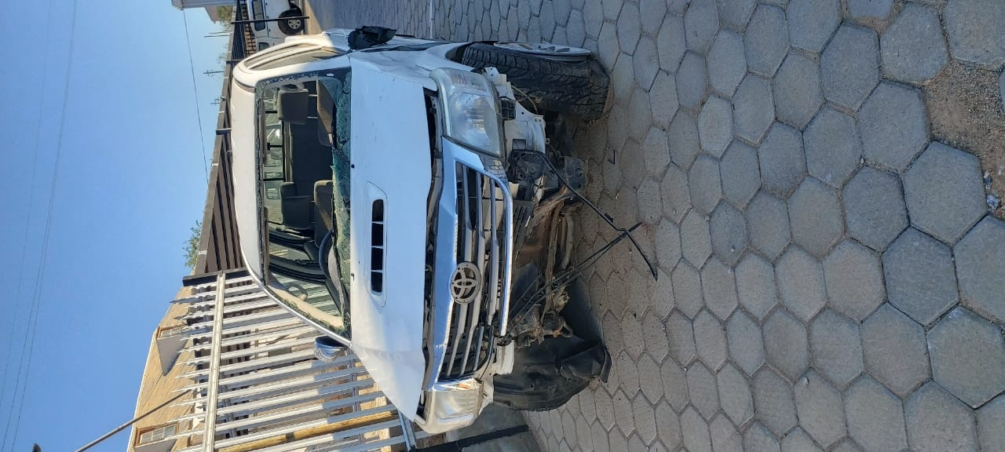

1. **VEHICLE DETAILS**

|  |  |
| --- | --- |
| * **Registration nr** | CA300002 |
| * **Make of Vehicle** | Ford Marathon |
| * **Engine nr** | 220**** |
| * **VIN:** | AFAMWFD17MR33**** |
| * **Year Model** | 2000 |
| * **Current kilometres** | 206000 |
| * Location | East pier, Cape Town Waterfront |

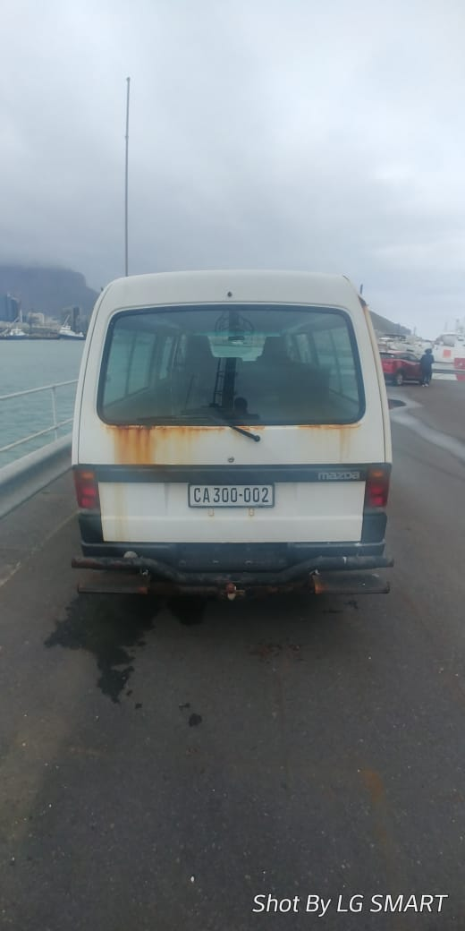

1. **VEHICLE DETAILS**

|  |  |
| --- | --- |
| * **Registration nr** | HS52BL GP |
| * **Make of Vehicle** | Nissan Almera |
| * **Engine nr** | TD2774**** |
| * **VIN:** | ADNJ420000E01**** |
| * **Year Model** | 2018 |
| * **Current kilometres** | 152000 |
| * **Location** | Environment House, Pretoria |

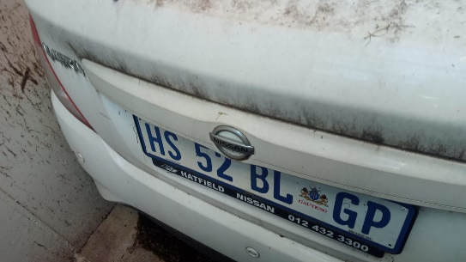 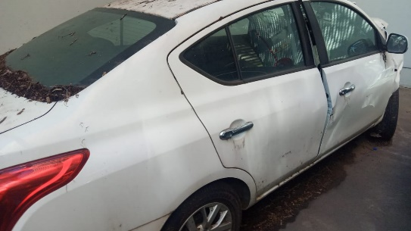

1. **VEHICLE DETAILS**

|  |  |
| --- | --- |
| * **Registration nr** | VPB 466GP |
| * **Make of Vehicle** | Opel Corsa |
| * **Engine nr** | 6W005**** |
| * **VIN:** | ADMXF68JG6437**** |
| * **Year Model** | 2007 |
| * **Current kilometres** | 200 000 |
| * **Location** | Environment House, Pretoria |

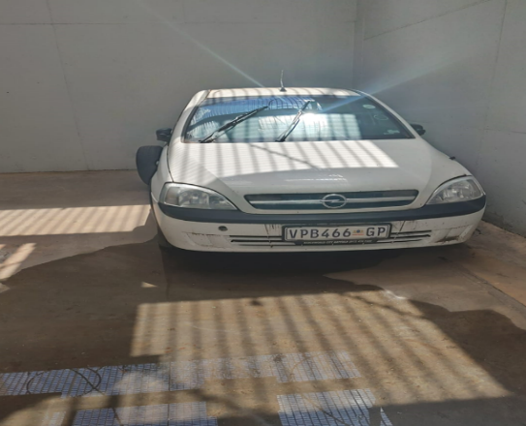

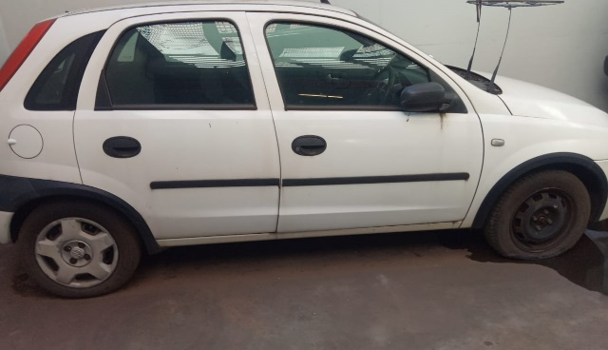

1. **VEHICLE DETAILS**

|  |  |
| --- | --- |
| * **Registration nr** | CX 84 LS GP |
| * **Make of Vehicle** | Renault Sandero |
| * **Engine nr** | K7MF710UH9**** |
| * **VIN:** | ADRBSRAFKUK41**** |
| * **Year Model** | 2014 |
| * **Current kilometres** | 286 718 |
| * **Location** | Environment House, Pretoria |

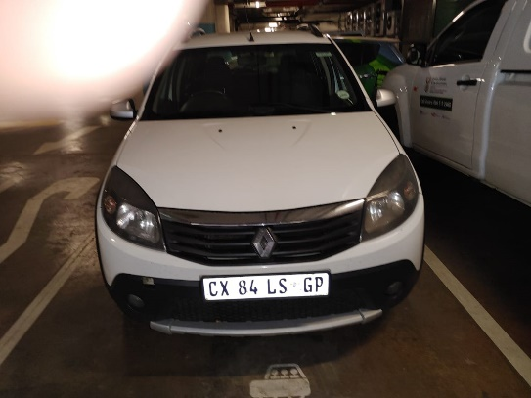 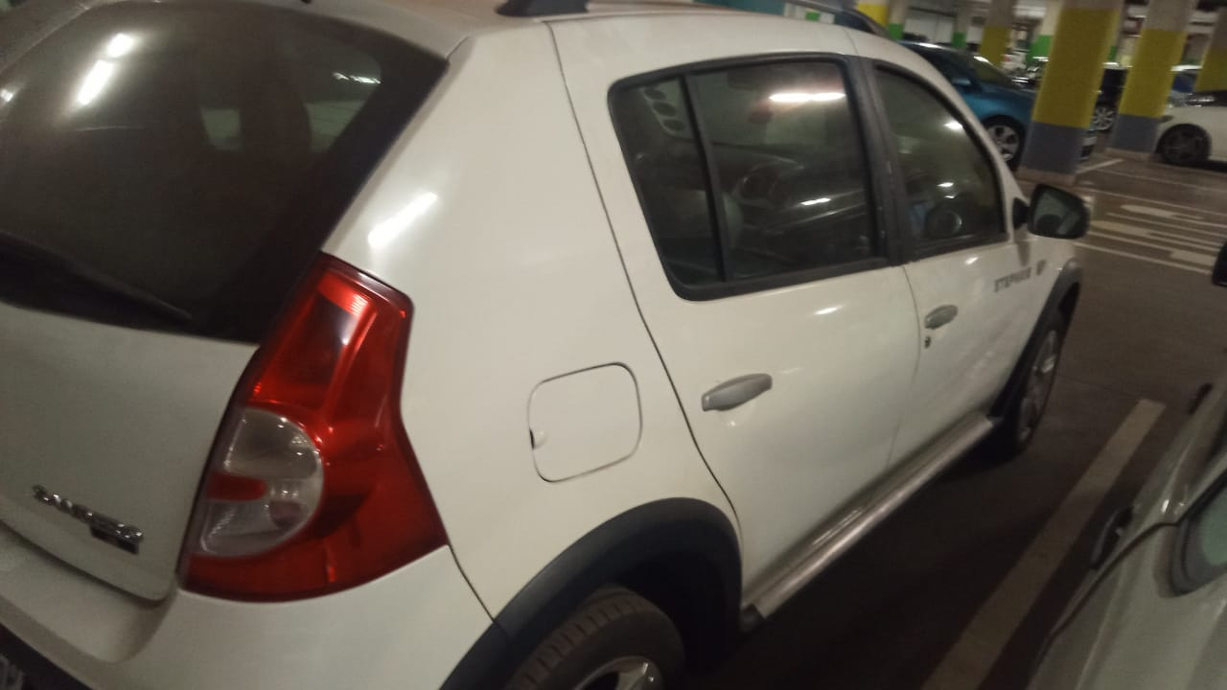

1. **VEHICLE DETAILS**

|  |  |
| --- | --- |
| * **Registration nr** | CX 88 XP GP |
| * **Make of Vehicle** | Renault Sandero |
| * **Engine nr** | K7MF710UH9**** |
| * **VIN:** | ADRBSRAFKUK41**** |
| * **Year Model** | 2014 |
| * **Current kilometres** | 209518 |
| * **Location** | Environment House, Pretoria |

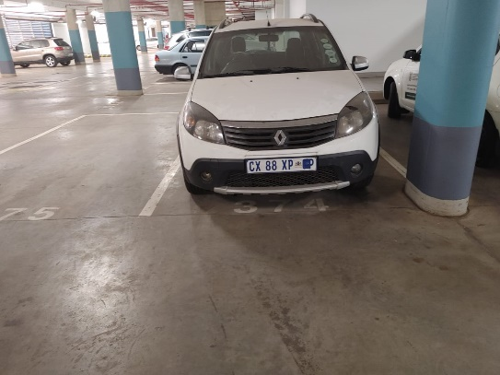 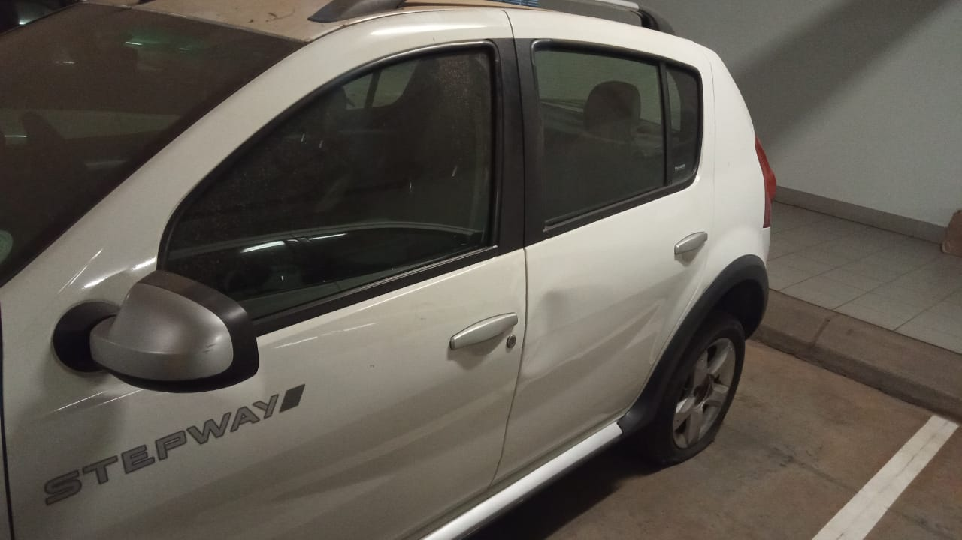

1. **VEHICLE DETAILS**

|  |  |
| --- | --- |
| * **Registration nr** | CX 88 XM GP |
| * **Make of Vehicle** | Renault Sandero |
| * **Engine nr** | K7MF710UH8**** |
| * **VIN:** | ADRBSRAFKUK41**** |
| * **Year Model** | 2014 |
| * **Current kilometres** | 204663 |
| * **Location** | Environment House, Pretoria |

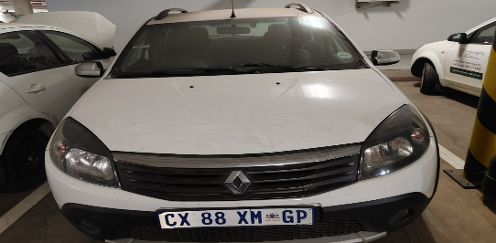 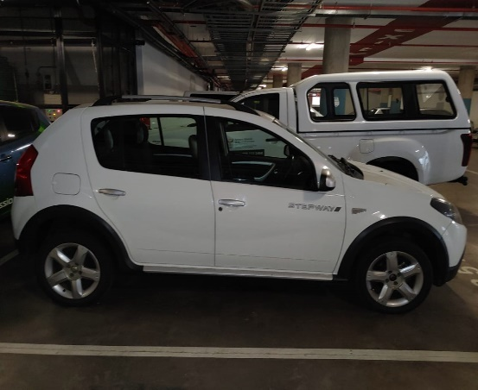

1. **VEHICLE DETAILS**

|  |  |
| --- | --- |
| * **Registration nr** | CY 74 KZ GP |
| * **Make of Vehicle** | Ford Ikon |
| * **Engine nr** | DE1**** |
| * **VIN:** | MAJBXXMRTBDE1**** |
| * **Year Model** | 2014 |
| * **Current kilometres** | 193425 |
| * **Location** | Environment House, Pretoria |

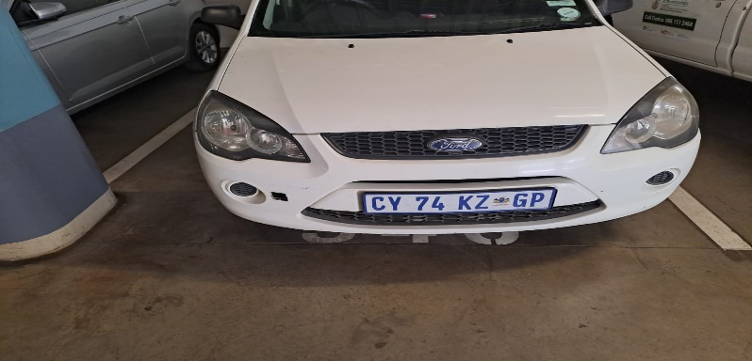

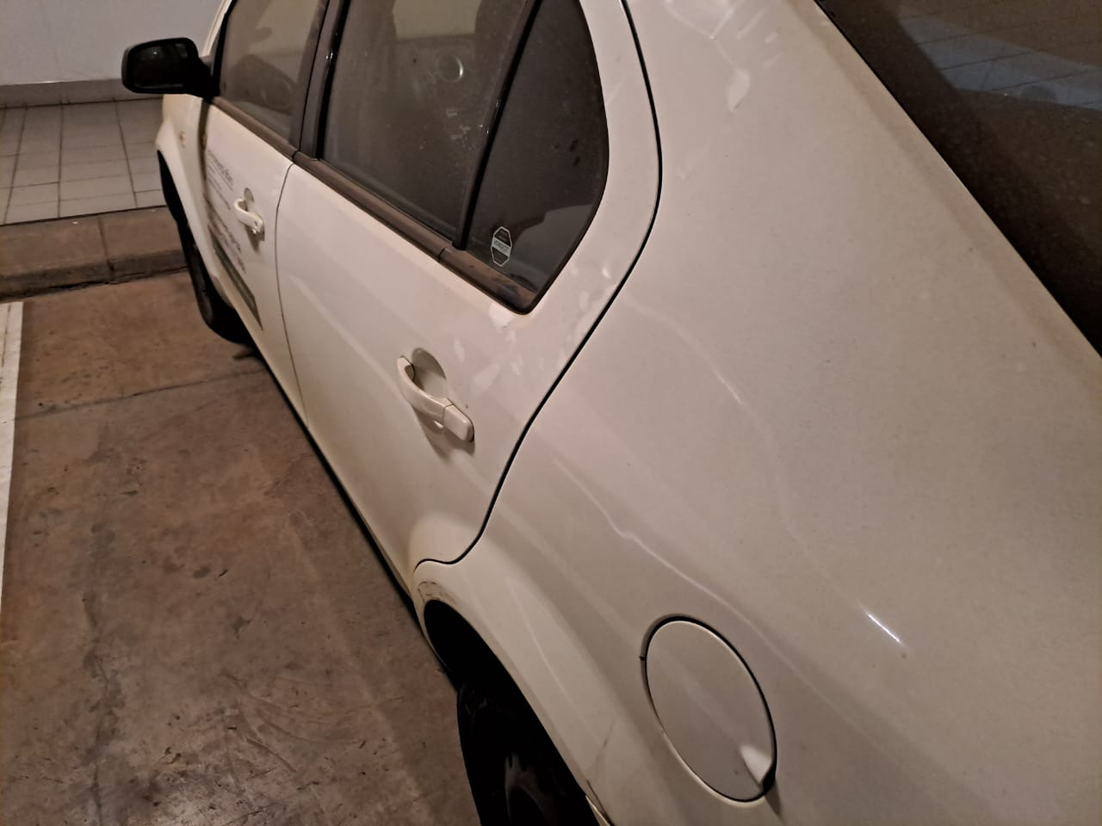

1. **VEHICLE DETAILS**

|  |  |
| --- | --- |
| * **Registration nr** | CY 74 NX GP |
| * **Make of Vehicle** | Ford Ikon |
| * **Engine nr** | DE1**** |
| * **VIN:** | MAJBXXMRTBDE1**** |
| * **Year Model** | 2014 |
| * **Current kilometres** | 169433 |
| * **Location** | Environment House, Pretoria |

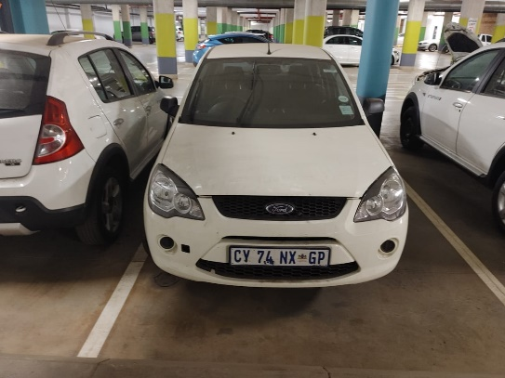

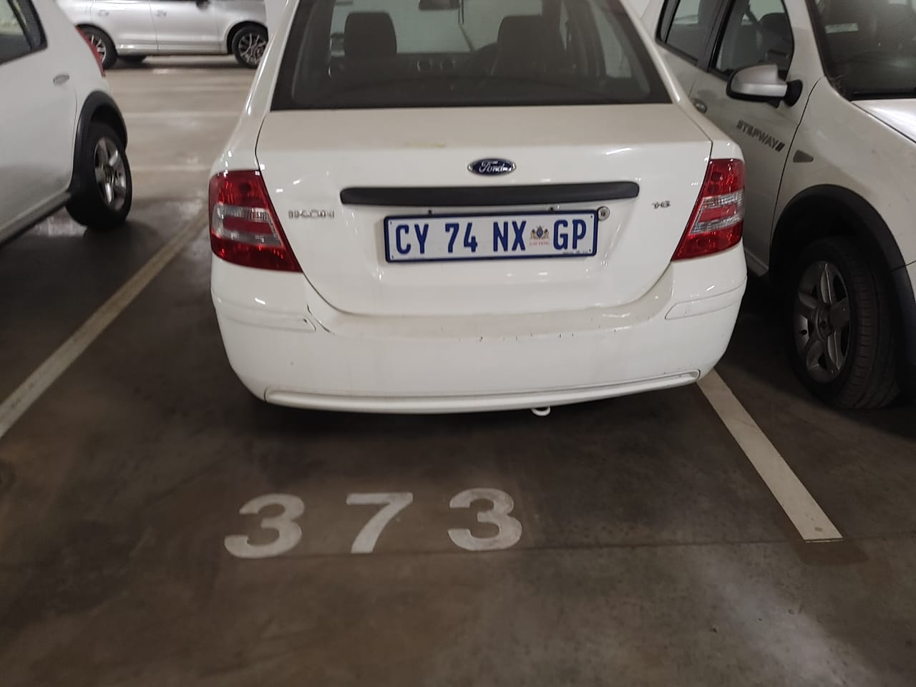

1. **VEHICLE DETAILS**

|  |  |
| --- | --- |
| * **Registration nr** | CY 74 MM GP |
| * **Make of Vehicle** | Ford Ikon |
| * **Engine nr** | DE1**** |
| * **VIN:** | MAJBXXMRTBDE1**** |
| * **Year Model** | 2014 |
| * **Current kilometres** | 191290 |
| * **Location** | Environment House, Pretoria |

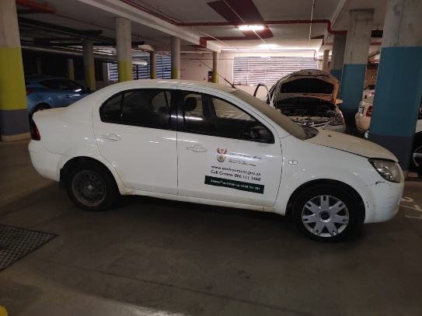 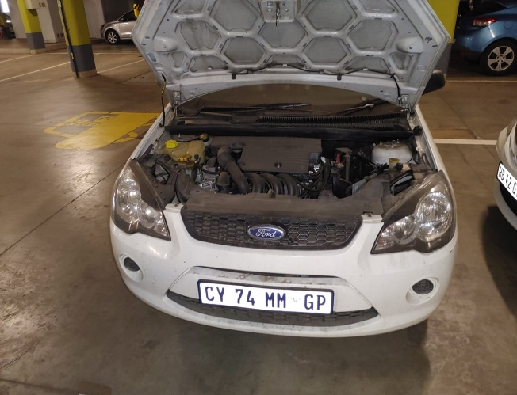

1. **VEHICLE DETAILS**

|  |  |
| --- | --- |
| * **Registration nr** | DJ 46 MF GP |
| * **Make of Vehicle** | Audi A8 |
| * **Engine nr** | CTEO0**** |
| * **VIN:** | WAUZZZ4HIEN01**** |
| * **Year Model** | 2014 |
| * **Current kilometres** | 152420 |
| * **Location** | Environment House, Pretoria |

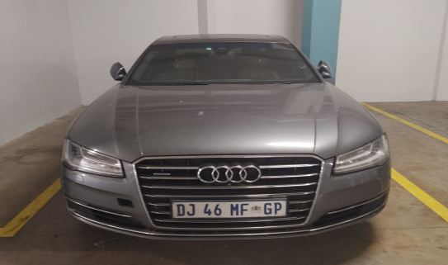 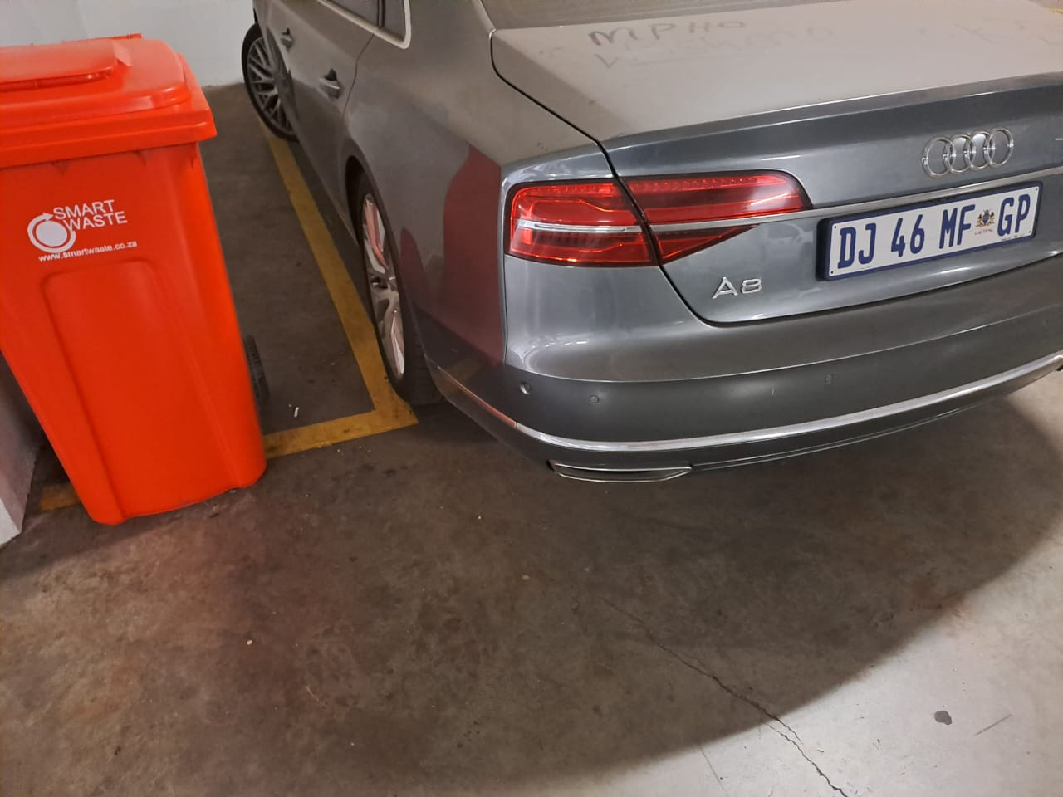

1. **VEHICLE DETAILS**

|  |  |
| --- | --- |
| * **Registration nr** | SVM 272 GP |
| * **Make of Vehicle** | BMW 530I |
| * **Engine nr** | 0600**** |
| * **VIN:** | WBANE72045CM1**** |
| * **Year Model** | 2005 |
| * **Current kilometres** | 120180 |
| * **Location** | Environment House, Pretoria |

