Grievance redress mechanism

For disclosure

16.12.2024

Development of value chains for products derived from genetic resources in compliance with the Nagoya Protocol on access and benefit sharing and the national biodiversity economy strategy

11 December 2024

# Acronyms

ESIA Environmental and Social Impact Assessment

ESMF Environmental and Social Management Framework

ESMP Environmental and Social Management Plan

GEF Global Environmental Facility

GRM Grievance Redress Mechanism

PMU Project Management Unit

RP Responsible Party

SES Social and Environmental Standards

SESP Social and Environmental Screening Procedure

SRM Stakeholder Response Mechanism

UNDP United Nations Development Programme

# Table of Contents

Acronyms 2

Table of Contents 3

1 Background 4

2 Definition of a GRM 5

3 Purpose of the GRM 5

3.1 Scope and eligibility 5

3.2 Objective 6

3.3 Principles 6

3.4 Awareness raising about the GRM 7

4 The Response Process for the Project 8

4.1 Overview of the grievance response process 8

4.2 Process for the Grievance Redress Mechanism 9

4.2.1 Step 1: Receive and Register Grievance 11

4.2.2 Step 2: Acknowledge, Assess and Assign Grievance 15

4.2.3 Step 3: Develop a Response 16

4.2.4 Step 4: Communicate Response and Seek Agreement 16

4.2.5 Step 5: Implement Response 18

4.2.6 Step 6: Review Resolution 18

4.2.7 Step 7: Close Out or Refer Request 19

4.2.8 Step 8: Monitoring and Evaluation 20

4.3 Project Assurance mechanism 20

5 Roles, Responsibilities and Resources 21

6 USE AND STORAGE OF SENSITIVE INFORMATION 22

Project Stakeholder Response Mechanism

# Background

In 2015, The Department of Environment, Forestry and Fisheries (DEFF) launched the National Biodiversity Economy Strategy (NBES). The Strategy is concerned with supporting the development of businesses and economic activities that are either directly dependent on biodiversity for their core business or that contribute to conserving biodiversity through their activities. In addition, the DEFF is the implementing partner for the UNDP-GEF 6 Project entitled,” Development of Value Chains for Products derived from Genetic Resources in Compliance with the Nagoya Protocol on Access and Benefit Sharing (ABS) and the National Biodiversity Economy Strategy (NBES).”

The project aims to support the implementation of the National Biodiversity Economy Strategy (NBES) by focusing on the use of indigenous plants' genetic resources and their current and potential applications, either in pharmaceuticals, personal care products, cosmetics, enzymes or similar non-food uses. It will address both conservation and Access and Benefit Sharing (ABS) issues linked to the development of different bioprospecting value chains, while also helping key players overcome related barriers and challenges.

The project addresses both conservation and Access and Benefit Sharing (ABS) issues linked to the development of different bioprospecting value chains and therefore key stakeholders to the project are rural populations, communities and holders of Indigenous Knowledge (IK). The project aims to positively impact on Human rights as per the Constitution of South Africa in the Bill of Rights. More specifically the project outcomes will progress towards improving the right to dignity, equality and freedom, to work, ending gender discrimination and securing cultural, economic and social rights of the people.

The project will approach its core problem both through ABS pilots and ABS systemic measures that are relevant for the ABS-conservation nexus of the bioprospecting segment. More specifically, the project will focus on bioprocessing and product development, and on removing barriers through R&D and stakeholder collaboration. The project will create opportunities and jobs through the development of value chains that utilise Indigenous Biological Resources’ (IBR). The development of these value chains will promote the growth of the bioprospecting economy while strengthening ABS linkages of communities to ensure maximum inclusion. Existing linkages between indigenous communities and IBR’s allow for the parallel development of both towards securing improved economic and social well-being. Key project outcomes include the following:

* Establish or improve ABS agreements between TK holders, organisations and players in the bioprospecting industry to improve fair and equitable compensation
* Improve access, quality and opportunity to utilise IBR’s for both indigenous communities, marginalised groups and key stakeholders
* Improve management structures maximising the fair and equitable allocation of benefits
* Facilitate training and financial support to communities to maximise opportunity for participation in the green economy
* The project will foster innovation, equitable sharing of benefits from genetic resources, while contributing to both species and habitat conservation.
* The project will enhance South Africa’s systemic capacity development for Nagoya Protocol compliance through gender-sensitive approaches

The project outcomes therefore manage potential social impacts in the space of fair and equitable access and benefit sharing in value chains that utilise Indigenous Biological Resources in line with the principles of conservation and sustainable use. Project outcomes therefore support the social and environmental safeguard landscape within this sector.

The Project is nonetheless anticipated to impact both directly and indirectly, positively and negatively on communities in the Project area and surrounding areas. These impacts can potentially affect the lives of people living and working in these communities, thus giving rise to grievances. These potential grievances may relate to any aspect of the Project and might be felt and expressed by a variety of parties including individuals, groups, communities, entities, or other parties affected or likely to be affected by the social or environmental impacts of the Project.

As a result, this document represents the Project’s Grievance Redress Mechanism (GRM) that ensures individuals, peoples, and communities affected by projects have access to appropriate grievance resolution procedures for hearing and addressing project-related complaints and disputes.

# Definition of a GRM

A Grievance Redress Mechanism (GRM) is an organizational system established by government agencies to address stakeholder concerns about the impact of policies, programs, and operations. GRMs provide an accessible, collaborative, and efficient way to resolve issues through dialogue and problem-solving and serve as a "first line" response to stakeholder grievances that proactive engagement has not prevented. GRMs are designed to complement, not replace, formal legal channels, as stakeholders always retain the option to pursue formal legal remedies. GRMs address general concerns, while issues involving corruption or serious rights violations are referred to formal accountability bodies.

# Purpose of the GRM

## Scope and eligibility

**Scope**

This GRM will be applied to stakeholder complaints and grievances, perceived or actual, which relate to the activities of the Project (Described above) and its Responsible Partners and Contractors’ activities in relation to project implementation. A complaint or grievance is an issue, concern, problem, or claim (perceived or actual) that an individual stakeholder or community group has related to the Project and its Responsible Partners and Contractors’ operations and activities. The mechanism does not impede access to judicial or administrative resolutions.

**Eligibility of complaints**

* **Eligible complaints**

To be eligible for a Project GRM response, the complaint must pertain to this Project and its activities. In addition, the complaint must:

* Indicate how Project activity(ies) have caused or contributed, or may cause or contribute to social or environmental harm
* Be made by a person or people (directly or through an authorized representative) who could plausibly be affected by the harm(s) referenced in the complaint.

If further information is needed to determine eligibility, the GRM should seek such information from the complainant before making an eligibility determination.

* **Non-eligible complaints**
* Any complaint that is found by the Project to have been filed fraudulently or maliciously.
* Complaints relating to projects that are not the described above Project.
* Complaints by people or groups who have already raised the same issue with respect to the same project and received an GRM response, unless significant new information is available or there has been a significant change in circumstances.
* Anonymous complaints.

## Objective

The Project’s Grievance Redress Mechanism (GRM) is intended to supplement proactive stakeholder engagement by the Project and its Responsible Partners throughout the project cycle. Effective stakeholder engagement creates opportunities to resolve issues that would otherwise lead to conflict. The GRM acts as recourse for situations in which, despite proactive stakeholder engagement, some stakeholders have a concern about a project or program’s potential impacts on them. The GRM is intended to be accessible, collaborative, expeditious, and effective in resolving concerns through dialogue, joint fact finding, negotiation, and problem solving.

The objective of this mechanism is to:

* Provide a predictable, transparent, and credible process to all parties for resolving grievances, resulting in outcomes that are seen as fair, effective, and lasting.
* Build trust as an integral component of broader community relations activities; and
* Enable more systematic identification of emerging issues and trends, facilitating corrective action and pre-emptive engagement.

## Principles

The guiding principles[1] for the design of the UNDP GRM are the following:

**a. Legitimate: enabling trust from the stakeholder groups for whose use they are intended, and being accountable for the fair conduct of grievance processes.** Accountability for ensuring that the parties to a grievance process cannot interfere with its fair conduct is typically one important factor in building stakeholder trust.

**b. Accessible: being known to all stakeholder groups for whose use they are intended, and providing adequate assistance for those who may face particular barriers to access.** Barriers to access may include a lack of awareness of the mechanism, language, literacy, costs, physical location and fears of reprisal.

**c. Predictable: providing a clear and known procedure with an indicative timeframe for each stage, and clarity on the types of process and outcome available and means of monitoringi mplementation.** Inorder for a mechanism to be trusted and used, it should provide public information about the procedure it offers.

**d. Equitable: seeking to ensure that aggrieved parties have reasonable access to sources of information, advice and expertise necessary to engage in a grievance process on fair, informed and respectful terms.** Where imbalances are not redressed, perceived inequity can undermine both the perception of a fair process and the GRM’s ability to arrive at durable solutions.

**e. Transparent: keeping parties to a grievance informed about its progress, and providing sufficient information about the mechanism’s performance to build confidence in its effectiveness and meet any public interest at stake.** Providing transparency about the mechanism’s performance to wider stakeholders, through statistics, case studies or more detailed information about the handling of certain cases, can be important to demonstrate its legitimacy and retain broad trust. At the same time, confidentiality of the dialogue between parties and of individuals’ identities should be provided where necessary.

**f. Rights compatible: these processes are generally more successful when all parties agree that outcomes are consistent with applicable national and internationally recognized rights.** Grievances are frequently not framed in terms of rights and many do not initially raise human rights or other rights concerns. Regardless, where outcomes have implications for rights, care should be taken that they are consistent with applicable nationally and internationally recognized standards and that they do not restrict access to other redress mechanisms.

**g. Enabling continuous learning: drawing on relevant measures to identify lessons for improving the mechanism and preventing future grievances and harms.** Regular analysis of the frequency, patterns, and causes of grievances; strategies and processes used for grievance resolution; and the effectiveness of those strategies and processes, can enable the institution administering the GRM to improve policies, procedures, and practices to improve performance and prevent future harm.

**h. Based on engagement and dialogue: consulting the stakeholder groups for whose use they are intended on their design and performance, and focusing on dialogue as the means to address and resolve grievances.** For an operational-level grievance mechanism, engaging regularly with affected stakeholder groups on the GRM’s design and performance can help to ensure that it meets their needs, that they will use it in practice, and that there is a shared interest in ensuring its success.

## Awareness raising about the GRM

The Project will proactively inform affected communities and the wider stakeholder group of the details of the GRM, either directly or through local level Responsible Partners or contractors. This will include information about where people can go and who they can talk to if they have a grievance. This information shall be widely and regularly publicised, throughout the duration of the public consultation exercise, through meetings and the distribution of fliers.

The information will be provided in a format and language that is readily understandable by the local population and/or orally in areas where literacy levels are low during routine stakeholder engagement.

# The Response Process for the Project

## Overview of the grievance response process

The GRM will function on two levels:

* At the Project Management level, under the direction of the Project Manager, supported by the project management unit.
* At UNDP level:
  + **Project Assurance**: if a complaint is not resolved at GRM level after 60 days, the complaint is refer to the Project Board as part of UNDP’s Project Assurance role in consultation with and in support of the Project Board. UNDP is responsible for the Project Assurance function, under the direction of the UNDP Deputy Resident Representative.
  + **Country Office Stakeholder Response Mechanism**: if the complaint is not resolved after 60 days at Project Assurance Level, the complaint is referred to UNDP Country Office (CO) Stakeholder Grievance Mechanism.
  + **Headquarter Stakeholder Response Mechanism:** if the complaint is not resolved through UNDP Country Office (CO) Stakeholder Grievance Mechanism, it is referred to UNDP Headquarter Stakeholder Response Mechanism**.**

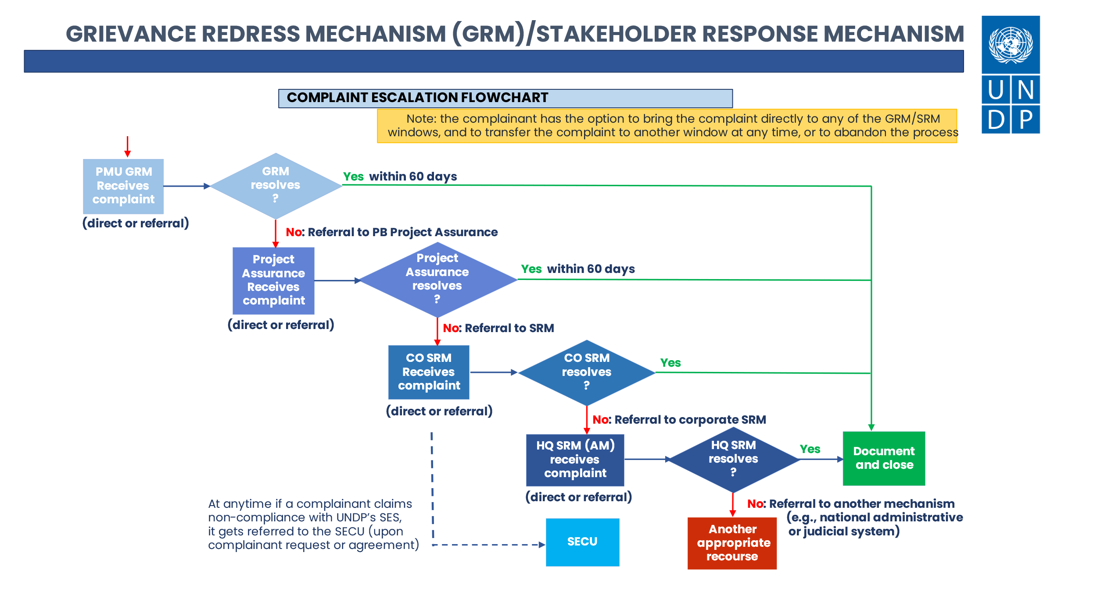

The complainant has the option to bring the complaint directly to any of the GRM or SRM windows, and to transfer the complaint to another window at any time, or to abandon the process. At anytime, if a complainant claims non-compliance with the UNDP’s Social and Environmental Standards (SES), it gets referred to the Social and Environmental Compliance Unit upon complainant request or agreement).

As the result of this two level mechanism, **the complainant can raise a compliant at any time through**:

1. Project Grievance Redress Mechanism – see section 4.2
2. UNDP Country Office Stakeholder Response Mechanism

* Visit the UNDP South Africa offices at 351 Francis Baard Street, UN House Level 08, Metropark Building
* Call, SMS or WhatsApp: 063 409 4761
* Email to [srm.za@undp.org](mailto:srm.za@undp.org)

Details on the SRM are available on [UNDP South Africa website](https://www.undp.org/south-africa/projects/stakeholder-response-mechanism-country-office-level).

1. UNDP SECU, if the complaint is relates to UNDP SES non compliance:

Email: [secuhotline@undp.org](mailto:secuhotline@undp.org)

Details on the SECU process available on [UNDP’s website](https://www.undp.org/accountability/audit/secu-srm/social-and-environmental-compliance-review).

## Process for the Grievance Redress Mechanism

The Grievance Response Mechanism must be a simple process whereby stakeholders can submit their complaints free of charge and, if necessary, anonymously or via third parties. It should allow responses to be submitted in more than one format.

The following process will be followed to address and resolve a grievance:

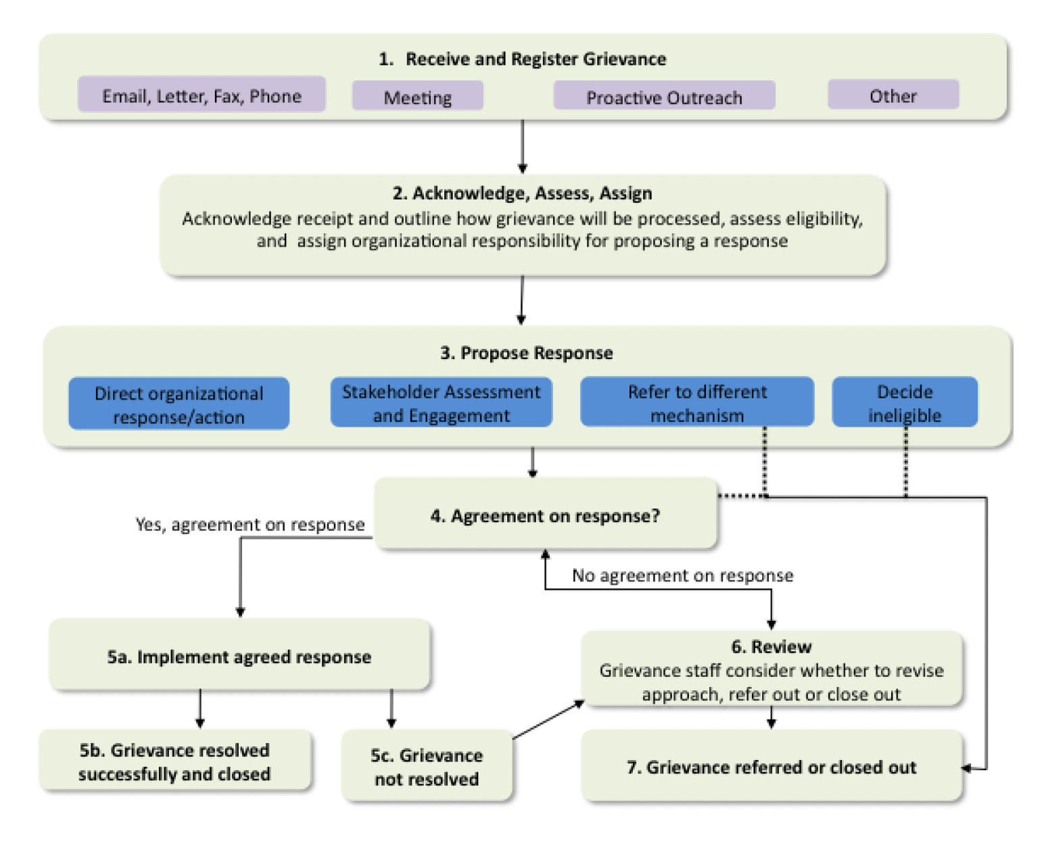

Source: *Guidance Note, UNDP Social and Environmental Standards (SES), Stakeholder Engagement, Supplemental Guidance: Grievance Redress Mechanism*

| **Process** | **Description** | **Time Limit** |
| --- | --- | --- |
| Step 1: Receive grievance | * Face to Face * Phone, Letter or Email * Completed and Submitted Complaint Form (online or in person or on behalf of complainant) * Community complaints or protests (verbal and non-verbal), including signs or road blocks | 5 working days |
| Step 2: Acknowledge, Assess and Assign Grievance Significance | * Register grievance * Report grievance * Assess eligibility * Log grievance on system with a number for tracking * Communicate receipt of grievance |
| Step 3: Develop a Response | * Develop an appropriate response and identify resolution depending on the significance |  |
| Step 4: Communicate Response and Seek Agreement | * Investigate and consult with relevant parties to fully understand issues and implement actions agreed upon * Communicate response back to the complainant * Agree on the proposed way forward to resolve grievance | 60 Days (from acknowledgement of receipt) |
| Step 5: Implement Resolution | * Where agreement is met, move forward with proposed action * Monitor success of resolution |
| Step 6: Review Response | * Communicate results of resolution to stakeholder * Identify if further action is required |
| Step 7: Close Out or Refer Request | * Close out the grievance if response is successful * Where unsuccessful, refer the grievance to the Project Assurance |
| Step 8: Monitoring and Evaluation | * Monitor ongoing success of the resolution * Results and to be included in project monitoring processes | ongoing |

### Step 1: Receive and Register Grievance

The process of reporting a grievance should be easily accessible. The preferable channels for reporting a grievance can be discussed with the community as part of community engagement including project or output level periodical meetings/forums/feedback sessions.

A grievance may be received by the PMU, Responsible Partner or Contractor representative and is then forwarded to the Grievance Manager. Grievances can be submitted:

* in writing
* telephonically
* or presented verbally to the local project representative, contractor or implementer utilising their relevant contact details.

Alternatively, grievances can be submitted in writing, telephonically or presented verbally to the Grievance Manager using the following details:

* Name: Mr Khuthadzo Mahamba – Grievance Manager- DFFE
* Email: [BiotradeZA@DFFE.gov.za](mailto:BiotradeZA@DFFE.gov.za)
* Address: Private Bag X447, Pretoria, 0001, Environment House, 473 Steve Biko Road, Pretoria, 0002
* DFFE Hotline: 086 111 2468

For people who require assistance, a claim may be filed by a trusted representative. Claims may be submitted in all official languages of South Africa. An anonymous[2] complaint option is available through the Complaint Form.

All stakeholder grievances shall be logged using the **Grievance Form** below:

**To be filled by complainant or on behalf of complainant**

|  |  |  |  |  |  |
| --- | --- | --- | --- | --- | --- |
| **Grievance Record** | | | | | |
| Reference No:  (Official Use Only) |  | | | | |
| Anonymous[3] | □ Yes | | □ No | | |
| Full Name |  | | | | |
| Gender | □ Male | □ Female | | | □ Other |
| Age |  | | | | |
| Contact Information: | Address/Village/Traditional Authority and Ward: | | | | |
| Telephone: | | | | |
| Email: | | | | |
| Preferred contact method | □ Letter | | □ Telephone | □ Email | |
| Preferred language for communication |  | | | | |
| **Grievance Description** | | | | | |
| Description of Grievance or Incident  *(What happened? Where did it happen? Who did it happen to? What is the result of the problem?)* |  | | | | |
| Date of Incident/ Grievance |  | | | | |
| Nature of Incident/ Grievance (tick one and include date) | □ One time incident/ grievance (Date________________) | | | | |
| □ Incident/ grievance happened more than once (Date________________) | | | | |
| □ On-going incident/ grievance (Date________________) | | | | |
| What would you like to see happen to resolve the problem? |  | | | | |
| Additional Comments: |  | | | | |

The Grievance Manager will log, document and track all responses received within the secure **grievances database** below. Grievances shall be assigned a case number and records of communication/consultation shall all be attached with the relevant entry and filed. The database shall be monitored regularly by the Grievance Manager for recurring responses so that appropriate mitigation can be developed. As a minimum the following information shall be recorded:

* Case number.
* Complainant’s name and contact details.
* Date of complaint.
* Details of complaint.
* Resolutions discussed and agreed with the party(is) in question.
* Actions implemented (including dates); and
* Outcome of the actions implemented.

Grievance database

|  |  |  |  |  |  |  |  |  |  |  |  |  |  |  |
| --- | --- | --- | --- | --- | --- | --- | --- | --- | --- | --- | --- | --- | --- | --- |
| **Case Number** | **Date of Complaint** | **Recipient** | **Complainant (Name and Contacts)** | **Description of Grievance** | **Priority** | **Step (1-8)** | **Resolutions Discussed** | **Actions Implemented (with dates)** | **Responsible for Resolution** | **Status (open/closed)- Outcome of actions** | **Findings** | **Resolution** | **Date of Sign-off** | **Additional Comments / Follow-up** |
|  |  |  |  |  |  |  |  |  |  |  |  |  |  |  |
|  |  |  |  |  |  |  |  |  |  |  |  |  |  |  |

### Step 2: Acknowledge, Assess and Assign Grievance

*Acknowledgement*

The Grievance Manager shall acknowledge receipt of any responses as soon as possible, but up to seven days from the date it was submitted and shall inform the complainant about the timeframe in which a response can be expected. A **Response Receipt Form** below shall be signed and a copy provided to the complainant.

**To be sent/delivered to complainant to acknowledge grievance received**

|  |  |
| --- | --- |
| **Grievance Receipt Form** | |
| Grievance Number: |  |
| Date Submitted: |  |
| Target Date for initial meeting to address grievance: |  |
| Name: |  |
| Address and Contact Details: |  |
| Grievance Received by: |  |
| Name of Grievance Coordinator |  |
| Contact Details of Grievance Co-ordinator | Telephone:  Email:  Address: |

Additional considerations on acknowledging grievances.

* Literacy levels should be taken into consideration when providing the complainant with the acknowledgment of receipt, and verbal acknowledgement should accompany a written acknowledgement.
* Where appropriate acknowledgement should be provided through the Grievance Manager.

*Assessment*

The following steps shall be performed in a timely manner to avoid delaying resolution of a grievance:

1. Determine whether the grievance is eligible.
   1. Eligible grievances include all those that are directly or indirectly related to the Project and that fall within the **scope** of the Grievance Response Mechanism as outlined above.
   2. Ineligible Complaints may include those that are clearly not related to the Project or its contractors’ activities, whose issues fall outside the scope of the Grievance Response Mechanism procedure or where other legal or community procedures would be more appropriate to address the grievance.
2. If the grievance is deemed **ineligible** it can be rejected however a full explanation as to the reasons for this must be given to the complainant and recorded in the Grievance Database.

*Assignment*

If the grievance is eligible, the Grievance Manager will convene a Grievance Management Team composed of the PMU Social & Environmental Safeguards Specialist and a PMU member relevant to the complaint (for instance, the PMU person responsible for the Output). The team will assign organisational responsibility for formulating a response. The Grievance Manager has the responsibility for coordinating the Project response to an eligible request.

|  |  |  |
| --- | --- | --- |
| **Grievance Record (Official Use)** | | |
| Grievance Number |  | |
| Date Submitted |  | |
| Target Date for Resolution |  | |
| Full Name: |  | |
| Address and contact details: |  | |
| Grievance received by: |  | |
| Name of Grievance Co-ordinator: |  | |
| Description of Grievance: |  | |
| Assessment of Grievance Level: |  | |
| Assign Organisational Responsibility |  | |
| Notification to UNDP CO | □ Yes | □ No |

The progress on process should be logged in the Grievance Database.

### Step 3: Develop a Response

The Grievance management team will obtain as much information as possible from the person who received the complaint, as well as from the complainant to gain a first-hand understanding of the grievance:

1. Analyse the problem.
2. Conduct necessary investigations and evaluations. Undertake a site visit, if required, to clarify the parties and issues involved. Gather the views of other stakeholders including project employees, if necessary and identify initial options for settlement that parties have considered.
3. If the grievance concerns physical damage, (e.g. crop, house, community asset) take a photograph of the damage and record the exact location as accurately as possible.

Explore potential solutions and mobilize additional additional resources persons such as Responsible Parties, PMU Manager and UNDP Country Office staff as necessary to propose a response to the grievance. The Grievance Manager is responsible for coordinating the process and convening meetings with additional resources persons.

### Step 4: Communicate Response and Seek Agreement

The Grievance Manager drafts a proposed solution and communicate it to all parties involved, including a written response to the complainant. Grievance Manager will submit a proposed resolution no later than 60 working days after receipt of the complaint. Upon receipt of the proposed resolution, the complainant will be asked to approve or disapprove the suggested actions, so that the complaint can be closed or considered for further investigation/mediation. The response should be in writing, in language that is easily accessible to the complainant. The Grievance Manager may also contact the complainant by telephone, or set up a meeting to review and discuss the proposed response.

The proposed response should include:

* A clear restatement of the complainants concerns by the Grievance Manager.
* A detailed description of the proposed response, with an explanation of why the Grievance Manager is proposing it; and
* A listing of the complainant’s choices, given the proposed response. (Those choices may include, among others: agreement to proceed; request for a review of an eligibility decision, a referral decision, or a plan for compliance review; further dialogue on a proposed action; or participation in a proposed assessment and engagement process.)
* The expected timeframe for resolution aiming to resolve any grievances within 60 days from the date that it was received.

The following template is populated by the Grievance Manager and sent to the complainant to seek agreement and continue with resolution.

|  |  |
| --- | --- |
| **Grievance Resolution Response** | |
| Grievance Number: |  |
| Date of Communication: |  |
| Name of Complainant: |  |
| Restatement of Grievance/ Concern |  |
| Proposed Solution/Response | Eligibility status: |
| Proposed Solution: |
| Explanation: |
| List of choices for moving forward | 1. Agreement to proceed with above solution. 2. Request for a review of an eligibility decision, 3. A referral decision, or 4. A plan for compliance review. 5. Further dialogue on a proposed action. 6. Request participation in a proposed assessment and engagement process 7. Other to be suggested by complainant |
| Target Date for Resolution | *(30 days from receipt of grievance)* |
| Grievance Received by: |  |
| Name of Grievance Coordinator |  |
| Contact Details of Grievance Co-ordinator | Telephone:  Email:  Address: |

### Step 5: Implement Response

It is essential that the complainant(s) fully understand both the proposed response, and what choices they can make after considering the proposed response. The complainant may or may not agree with the proposed response. If there is agreement, then the Grievance Manager can proceed with the proposed response. Actions agreed upon during mediation will be implemented in a timely manner. Ideally, a timeline will have been established and documented for the implementation of the respective actions during the mediation or in the immediate response to the problem prior to the mediation.

The progress should be logged in the Grievance Database. If possible, the resolution of the complaint shall be made publicly available to keep other interested parties informed about the process and its outcome. However, this will be decided according to the privacy preferences of all parties involved. The Grievance Manager is responsible for overseeing the implementation of agreed actions to resolve the complaint.

### Step 6: Review Resolution

It is important for the Grievance Manager and the stakeholders to monitor implementation jointly. Where implementation of agreements reached is a multi-step process, and there is some implementation risk, the Grievance Manager should seek commitments from all stakeholders to “come back to the table” when needed to deal with challenges during implementation.

The Grievance Manager is to populate the template below, in line with agreed response on a given grievance and monitor progress.

|  |  |  |  |
| --- | --- | --- | --- |
| **Actions to Resolve Grievance (Official Use)** | | | |
| Delegated to: |  | | |
| Action | Who | When | Completed (Y/N) |
|  |  |  |  |
|  |  |  |  |
|  |  |  |  |
|  |  |  |  |
| Strategy to communicate response: |  | | |
| Response/ Resolution: |  | | |
| Sign-Off: |  | | |
| Date: |  | | |

### Step 7: Close Out or Refer Request

The final step is to close out the grievance. If the response has been successful, the Grievance Manager should document the satisfactory resolution. In cases where there have been major risks, impacts and/or negative publicity, it may be appropriate to include written documentation from the complainant indicating satisfaction with the response. In others, it will be sufficient for the Grievance Manager to note the action taken and that the response was satisfactory to the complainant and the organization/program. Once sign-off has occurred, this should be recorded in the Grievance Log.

If the grievance has not been resolved, the Grievance Manager should document steps taken, communication with the complainant (and other stakeholders if there has been substantial effort to initiate or complete a multi-stakeholder process), and refer the grievance to the Project Assurance (Section 4.3). The Grievance Manager needs to document the outcome of the discussions with the complainant in a way that makes clear what options were offered through the GRM and why the complainant chose not to pursue them.

To be completed by the Grievance Manager once all actions agreed upon have been completed

|  |  |  |  |  |  |
| --- | --- | --- | --- | --- | --- |
| **Conclusion** | | | | | |
| Is complaint Satisfied? | □ Yes | □ No | Comments from Grievance Manager: |  | |
| Is Grievance Closed? | □ Yes | □ No | Grievance Resubmitted? | □ Yes | □ No |
| Signature of Project Manager: |  | | Date: |  | |
| Date: |  | | New Grievance Number: |  | |

### Step 8: Monitoring and Evaluation

The project will monitor grievances routinely as part of the broader management of the Project. This entails:

* Monitoring may be as simple as a telephone call with the complainant and a discussion with the PMU to confirm that a relatively straightforward response has been fully implemented. On the other hand, effective monitoring may require ongoing meetings of a multi-stakeholder group that has reached agreement (e.g. to review implementation of a set of commitments for consultation with indigenous people, or implementation of a new approach to developing a voter registry).
* On receipt of grievances, electronic notification to the Project manager will be distributed.

Grievance records will be made available to the PMU at all times. Quarterly internal reports will be compiled by the Grievance Manager and distributed to the management team. These grievance reports will also be included in the quarterly progress reports and will include:

* The number of grievances logged in the proceeding period by level and type.
* The number of grievances unresolved after 60 days.
* The number of grievances of the same or similar issue.
* The measures taken to incorporate these responses into project design and implementation.

These reports and other records will be made available for external review if required. Grievance reporting will be part of the Projects’ annual reporting.

## Project Assurance mechanism

Complainants who are not satisfied with the Project Management GRM response (Section 4.2), or who are concerned about an adverse response, may bring their complaint to the Project Assurance function of the Project Board which is exercised by UNDP. In addition, UNDP Project Assurance will receive unresolved complaints referred to the Project Manager.

Complaints submitted to the UNDP Project Assurance function will be addressed per the procedures outlined below. UNDP will seek resolution of complaints together with national and other relevant partners (e.g. Implementing Partner, other members of the Project Board), with due consideration of confidentiality if requested by Complainants. The process for addressing complaints submitted to the UNDP Project Assurance function would typically involve the Project Manager and any necessary staff, external mediators, etc., under the direction of the UNDP Resident Representative and/or Deputy Resident Representative. For complaints referred from the Grievance Manager, the Project Assurance function will:

1. Log and track the complaint.
2. Review documentation received from the Grievance Manager and consult with the Grievance Management Team on the case.
3. Within 5 days of receipt, engage with the complainant to review and clarify the issues raised in the case and explore options for resolution (with the option to provide technical assistance to the complainant to support the complainant’s effective engagement).
4. As appropriate, engage with senior representatives of the Implementing Partner and other Project Board members to clarify issues and explore options for resolution.
5. As appropriate, play a mediating role between the parties to seek resolution of the complaint (with the option to contract with an external mediator).
6. When risks are identified that may affect overall project governance (e.g. potential need to put project components on hold or change the design of the project), ensure that the Project Board has full information about the risks and guides project decision making on the appropriate response;
7. Support the Project Board to address and remedy risks and harms that the project is demonstrably causing or to which it is demonstrably contributing.
8. If the complaint is resolved within 60 days of receipt, document the complainant’s acceptance of resolution, and continue to monitor until all project actions that were agreed to as part of the resolution have been taken.
9. If the complaint is unresolved 60 days after referral to the project assurance function (or if requested by the complainant at any time), offer the complainant the option of referral to the UNDP Stakeholder Response Mechanism and/or to any national institutions that have a mandate to address the issues raised.

For complaints received directly from Complainants, the Project Assurance function will first make an eligibility determination (identical to step 2 of the operational Project Management level of the GRM outlined above) and then continue from step 2 of the Project Board process as outlined above, except that step 2 for complaints that are received directly by the Project Assurance function will be “Consult with the Grievance Manager on the case, protecting Complainant confidentiality if requested.”

# Roles, Responsibilities and Resources

Implementation of the Stakeholder Response Mechanism for the Project will be the ultimate responsibility of the Grievance Manager. The Grievance Manager will be supported by the broader Project, Responsible Partners and Contractors. The various roles and responsibilities are as follows:

| **Responsible person** | **Roles** |
| --- | --- |
| **Grievance Manager** | * Coordinate the Grievance Redress Mechanism procedure, management system and recording as per the steps described in Section 4.2 providing guidance on solutions to complaints and grievances in consultation with the relevant departments and ensure consistency of redress for all grievances received in relation to the Project. * Coordinate the work of investigation of the Grievance management team * Promote awareness raising about the Grievance Redress Mechanism to all stakeholders in the project * Coordinate with the Project Assurance, the Country Office SRM, the HQ SRM and the SECU in the investigation of grievances and the agreement of redress that were directly received or referred to these accountability mechanisms. |
| **All Responsible Partners and Contractors** | * Receive and acknowledge any issue, concern, complaint or grievance from the community, verbally or in writing. They will record the issue and report it to the Grievance Manager in compliance with the Grievance Redress Mechanism procedure. * Involvement in the investigation of grievances as required depending on the nature and severity of the grievance and as directed by the Grievance Management team. |
| **Project Manager** | * Ensure that this Stakeholder Response Mechanism procedure is applied through all Project and its Responsible Partners and Contractors’ operations and activities * Apply necessary controls to minimise risks that could result in stakeholder grievances. |
| **Project Assurance** | * Review complaints received by the GRM and their outcomes, work with the Grievance Manager to identify successes, lessons learned, challenges and trends, and report its assessments to the Project Board. Should an outcome to a grievance be compensation, the UNDP Project Assurance function is responsible for confirming this outcome and for working with the Project Board to determine how compensation will be achieved as necessary. * Receive quarterly reports on complaints from the Project Management level of the GRM, and collaborate with its staff to identify successes, challenges, trends and lessons learned in responding to complaints. * Provide summary reports to the PB of all complaints received (both those received by the operational level GRM and directly by the Project Assurance function) with any recommended actions. * Disclose the GRM’s work (including case registry, summary reports on individual cases, reports on trends or patterns, and actions taken in response to trends and patterns) to the PB and to project stakeholders, through periodic reporting (at least semi-annual) in media/forums accessible to project stakeholders and protecting confidentiality of complainant identities where necessary; * Monitor the Grievance Manager’s efforts to inform project stakeholders about the GRM, and ensure the accessibility, predictability, transparency, legitimacy, and credibility of the GRM process; * Provide continuing education of PB members and their respective institutions regarding policies, procedures, and capacities needed to prevent risks and impacts which could lead to complaints, and to promote the constructive resolution of complaints. |

# USE AND STORAGE OF SENSITIVE INFORMATION

Information collected in relation to grievances can contain the personal details of the complainants, and sensitive material. As such, the utmost care must be taken to maintain confidentiality and protect this sensitive information.

In South Africa, the Protection of Personal Information Act No.4 of 2013, commonly known as “POPIA”, regulates and provides guidelines for the collection, storage and use of sensitive data from individuals. The POPIA seeks to protect natural and juristic persons from harm by protecting their personal information and sets out eight conditions for the lawful processing of personal information, thus balancing the right to privacy against other rights, particularly the right of access to information.

The eight conditions are set as follows (South Africa, 2013):

* Personal information may only be processed in a fair and lawful manner and only with the consent of the data subject or a competent person where the data subject is a minor.
* Personal information may only be processed for specific, explicitly defined and legitimate reasons.
* Personal information may not be processed for a secondary purpose unless that processing is compatible with the original purpose.
* Reasonable steps will be taken to ensure that the personal information collected is complete, accurate, not misleading and updated where necessary.
* The data subject whose information is collected will be made aware that NT is collecting such personal information and for what purpose the information will be used.
* Processing is necessary to carry out actions for the conclusion or performance of a contract to which the data subject is party.
* Personal information will be kept secure against the risk of loss, unlawful access, interference, modification, unauthorised destruction and disclosure.
* Data subjects may request whether their personal information is held, as well as the correction and/or deletion of any personal information held about them.

The POPIA states that an individual also has:

* The right to know what information is being kept, how it is being used, and when the National Treasury (NT) may disclose it;
* the right to correct their details - the NT will keep information updated or as captured by the data subject; and
* the right to revoke consent - individuals may revoke the consent that has been given in writing and addressed to the Information Officer or Deputy Information Officer(s) at PAIA@treasury.gov.za.

In light of the POPIA, information related to individuals and stakeholders in the Project will be dealt with as follows:

* All grievances are dealt with confidentially, following the process describe in this document.
* All complainants are informed about how their complaint is handled confidentially and how their information is secured and stored.
* The Grievance Register and any related documentation (including signed forms, photographs, written statements, and other supporting evidence) shall be kept in a secure online ‘cloud’-based facility (e.g. Google Drive).
* Access to the Register will be restricted to Project management and individuals named in Annex P-6-III only, along with oversight roles with contractual responsibilities to the project (e.g. OE Environmental & Social Safeguards Lead) so that they can perform audits efficiently and maintain regular oversight of the GRM process. Anyone with access must have a dedicated login profile (password protected) and must not share their login details with anyone else.
* Offline copies of the Grievance Register, parts of the register or any completed forms will not be generated, printed or shared at any time.
* At no time will any of the information contained in the Grievance Register, or any other information pertaining to grievances, be shared publicly or with third parties which are not contractual partners in the Project.
* Reporting of GRM performance (in reports which are likely to become public, such as the Quarterly Safeguards Report) will be anonymous – all names and contact details, and any other identifying information, will be removed from reported data. Results will be reported in aggregate (i.e. not referring to any individual grievances or complainants).

1. UNDP Guidance Note on GRM, 2017: <https://ses-toolkit.info.undp.org/sites/g/files/zskgke446/files/SES%20Document%20Library/Social%20and%20Environmental%20Standards/Supplemental%20Guidance_Grievance%20Redress%20Mechanisms.pdf>
2. not identified by name
3.