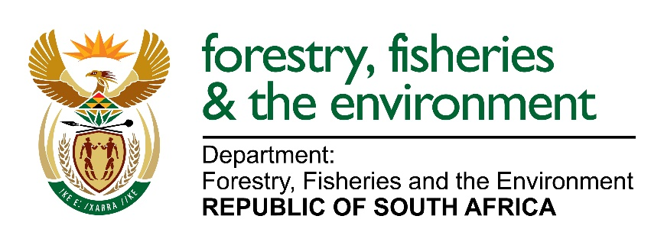

WILDLIFE ECONOMY PROGRAMME DATABASE APPLICATION FORM

Prepared by:
Directorate: Wildlife Economy
Department of Forestry, Fisheries, and the Environment
437 Steve Biko Street, Environment House, PRETORIA, 0001
Tel: 012 399 9595

Name of the Business/CPA
Description
Background about the property
Farm/Ranch Ownership | Female |  | Male |  | Youth |  |  | People With Disabilities
Animals | Species: |  |  |  |  | Total No. all Animals:
Hectares of Land

Location (Address, Coordinates etc.)
Core business activities
Partnership arrangements and periods with other parties (if any)
Partnership Activities
Infrastructure Available

Infrastructure Requirements
Minimum capital investment required:
Current Employment | Female | Male |  | Youth |  |  | People With Disabilities
Projected Employment | Female | Male |  | Youth |  |  | People With Disabilities
Business Successes/milestones
Business Challenges
Support provided by any other Government Department or Funding Agency
Date of Submission to DFFE

Approved or Not Approved by:
Mrs Lactitia Tshitwamulomoni
Director: Wildlife Economy
Date:

