
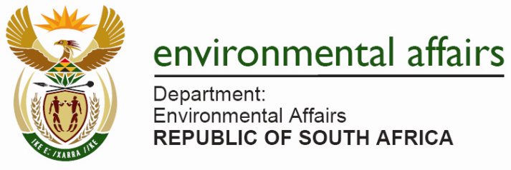

MILESTONE CATEGORY NOMINATION FORM

NUMBER OF SUCCESFUL ADMINISTRATIVE ENFORCEMENT NOTICES ISSUED

Important Notes:

This document must be read with the final background information document which is attached hereto.

Only applicable where there has been a successful outcome in relation to the final administrative enforcement notice has been achieved.

Officials who further play a critical role in assessing the quality of the final notices whose inputs leads to eventual compliance to final administrative enforcement notices may be considered for an award in this category. Evidence must however be submitted to justify being considered for an award under this category eg. before and after photographs, site inspection reports and/ or inputs via track changes – Please complete the table attached as Annexure A.

EMIs are entitled to nominate themselves, however the information must reach the DEA through the respective WGIV member. It is up to the WGIV member to ensure the validity of the information from the EMI.

Information may also be cross referenced against the statistics received in the National Compliance and Enforcement Reports 2006 -2013.

Milestone Category (please only mark one with an X)
35  Bronze |  | 50  Silver |  |  | 100  Gold
Details of EMI nominated
Name
Surname
Institution
Postal Address
Street Address
Telephone (W)
Telephone (H)
Cell number
Email
Person nominating the EMI
Name
Postal Address
Street Address
Telephone (W)
Telephone (H)
Cell number
Email
Your relationship with the EMI nominated
Who completed this nomination form? If the form was completed by someone other than the EMI please indicate your relationship with the EMI.

Annexure A

Case particulars | Behaviour being addressed eg. Non- compliance with conditions of an authorisation, rehabilitation or stopping the damage causing activity. | Evidence attached to show compliance with final instructions eg. Photographs, site inspection reports, track changed document, media articles.

This nomination form is for the purpose of presenting awards of excellence at the 2013 Environmental Compliance and Enforcement Lekgotla, an event managed by the Department of Environmental Affairs.

Fax or email the completed form to the Assistant Director: Capacity Development and Support (EMI Legal Support), Department of Environmental Affairs, Tel no. 012 310 3046 and email hvanschalkwyk@environment.gov.za

Nominations close on 28 October 2013.

