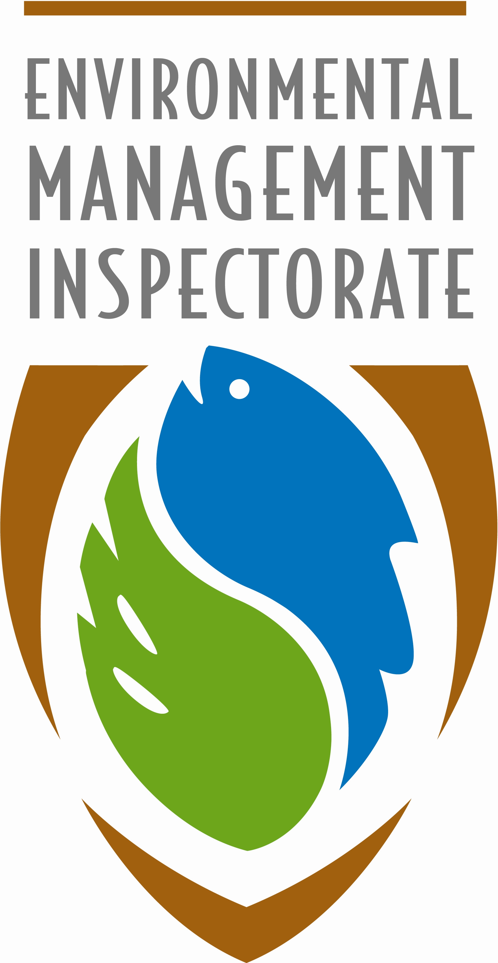
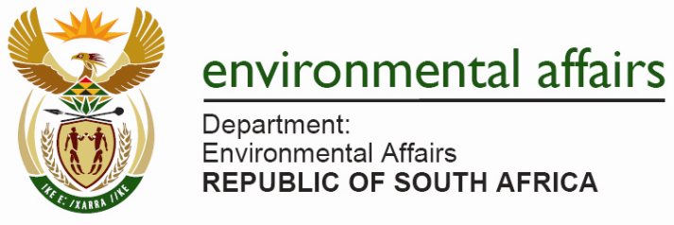

MILESTONE CATEGORY NOMINATION FORM

NUMBER OF SUCCESFUL INVESTIGATIONS UNDERTAKEN

Important Notes:

This document must be read with the final background information document which is attached hereto.

Only cases where a magistrate/judge has made a ruling will serve as admissible evidence to justify for an award under this category. All reported cases should feature on the EMI CAS system. J534’s does not qualify unless the EMI has pursued the non-payment of a fine through a criminal trial process. Information may be verified by drawing the personal profile of the EMI from the SAPS register.

It is also important to note that the award serves to acknowledge whether the investigation resulted in a successful prosecution, however, in the event of an unsuccessful outcome reasons may be given to justify why those cases should be considered.

The table attached to the nomination form must be completed by supplying the DEA with the necessary information.

EMIs are entitled to nominate themselves, however the information must reach the DEA through the respective WGIV member. It is up to the WGIV member to ensure the validity of the information from the EMI.

Information may also be cross referenced against the statistics received in the National Compliance and Enforcement Reports 2006 -2013.

Milestone Category (please only mark one with an X)
15  Bronze |  | 35  Silver |  |  | 50  Gold
Details of EMI nominated
Name
Surname
Institution
Postal Address
Street Address
Telephone (W)
Telephone (H)
Cell number
Email

Person nominating the EMI
Name
Postal Address
Street Address
Telephone (W)
Telephone (H)
Cell number
Email
Who completed this nomination form? If the form was completed by someone other than the EMI please indicate your relationship with the EMI.

Annexure A: Case Details

Case particulars – Details of offence | SAPS case number | EMI CAS number | Outcome of particular matter  Successful Yes/No | Details why unsuccessful cases should be considered

This nomination form is for the purpose of presenting awards of excellence at the 2013 Environmental Compliance and Enforcement Lekgotla, an event managed by the Department of Environmental Affairs.

Fax or email the completed form to the Assistant Director: Capacity Development and Support (EMI Legal Support), Department of Environmental Affairs, Tel no. 012 310 3046 and email hvanschalkwyk@environment.gov.za

Nominations close on 28 October 2013.

